**Instagram marketing strategy**

* Open an account on Instagram
* Encourage people to share information
  + Incentives to follow
  + Incentives to post on your story
* User statistics
  + 800 million monthly users
  + 500 million active on a daily basis
  + 1/3 of the most viewed stories are from businesses
  + Instagram advertising potential is 849.3M users
* Pay influencers
* 73% of them follow brands on social media because of the sales and products they are offering
* Encourage User Generated Content
* Post the same product more than once
  + 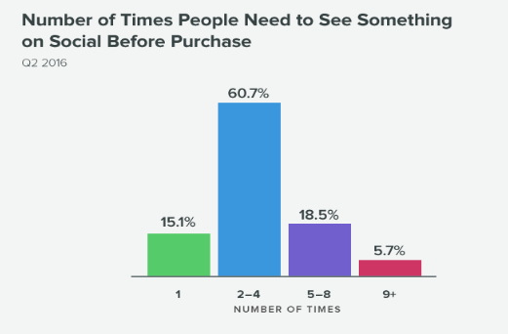
  + From the Sprout Social
  + 
   